Technology is often reduced to initials, like IT, AI and LLM; metaphors: Data Warehouses, Data Lakes, the Cloud, etc.; and occasionally oxymorons, notably Artificial Intelligence. ‘Artificial Intelligence’ suggests that AI is fake and therefore untrustworthy. I offer another Metaphor, ‘Data Bulldozer’ to describe a powerful technology .

AI is a Bulldozer for Moving Mountains of Data
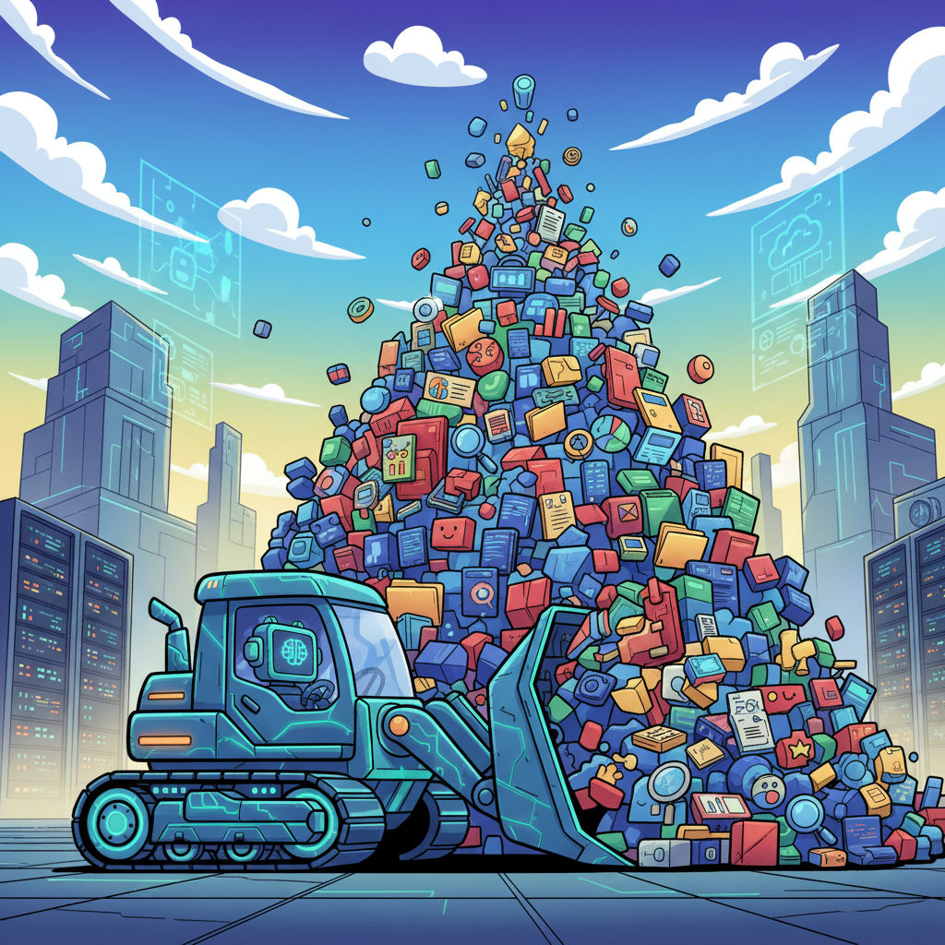
It’s Clearing a Space for Human Wisdom to Flourish.
Data are the numbers, words and images, we accumulate to count, measure and describe entities. Entities - the tangible things we count, measure and describe - are people, objects, places and activities. When we discover entity relationships, it's learning. When we commit what we learn to memory, it's knowledge. When knowledge is associated with consequences, it's intelligence. The lack of accurate data or the inability to identify entity relationships creates uncertainty. A doctor facing a patient with ambiguous symptoms, a parent deciding how to discipline their child, a leader choosing between competing values - in these moments we rely on personal wisdom to make decisions.
Human wisdom is not captured in AI models! Wisdom emerges from lived experience, ethical judgment, and understanding consequences beyond what data can capture. Wisdom incorporates emotion, intuition, moral values, and the humility that comes from making mistakes and bearing their weight.
Paradoxically, AI may be essential for advancing human wisdom precisely because it handles what wisdom doesn't require. By processing vast amounts of data, identifying patterns, and managing complexity at scale, AI frees humans from information overload. This creates space for the reflective, experiential, and moral dimensions of wisdom to flourish.
AI can show us what the data says; wisdom helps us decide what we should do about it. AI can reveal correlations; wisdom discerns meaning and purpose.
Our relationship with AI is complementary, not competitive. AI extends our analytical reach, but wisdom remains uniquely human- grown through struggle, relationships, and the accumulated weight of choices that matter. In this partnership, AI makes us more capable, but wisdom makes us more human. AI is the powerful ‘bulldozer’ we need to move mountains and build empires.
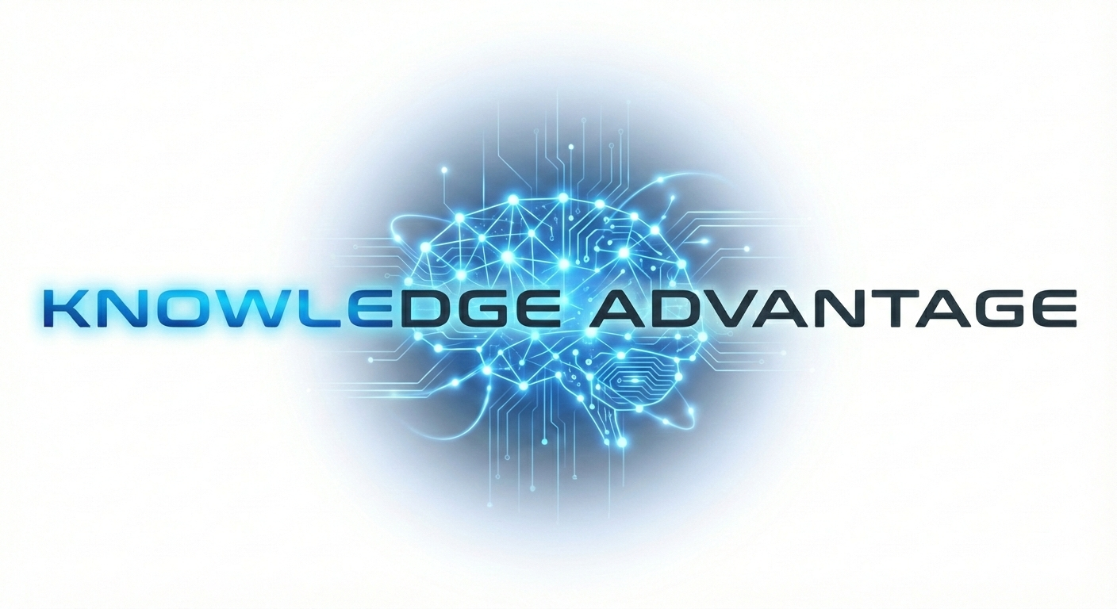
Knowledge Advantage is a ‘Critical-Learning’ Platform - a Visual, Interactive, and Adaptive approach to supplementing human wisdom. It’s currently being developed for educating patients, caregivers, and families to help them live with chronic diseases. This Critical-Learning Platform leverages AI technology to personalize the learning experience. This experience a Learning-graph for example this Interactive Learning Graph identifies the medications associated with dementia:

